Data Centre

(CSI-DC-BATCH-6)-24NAG2171

NAME: Mercy Joel Vunnamatla

EMAIL: joel.mercy000@gmail.com

CLOUD LAB ID: 24NAG2171-10

Installing Windows

Practical : VM

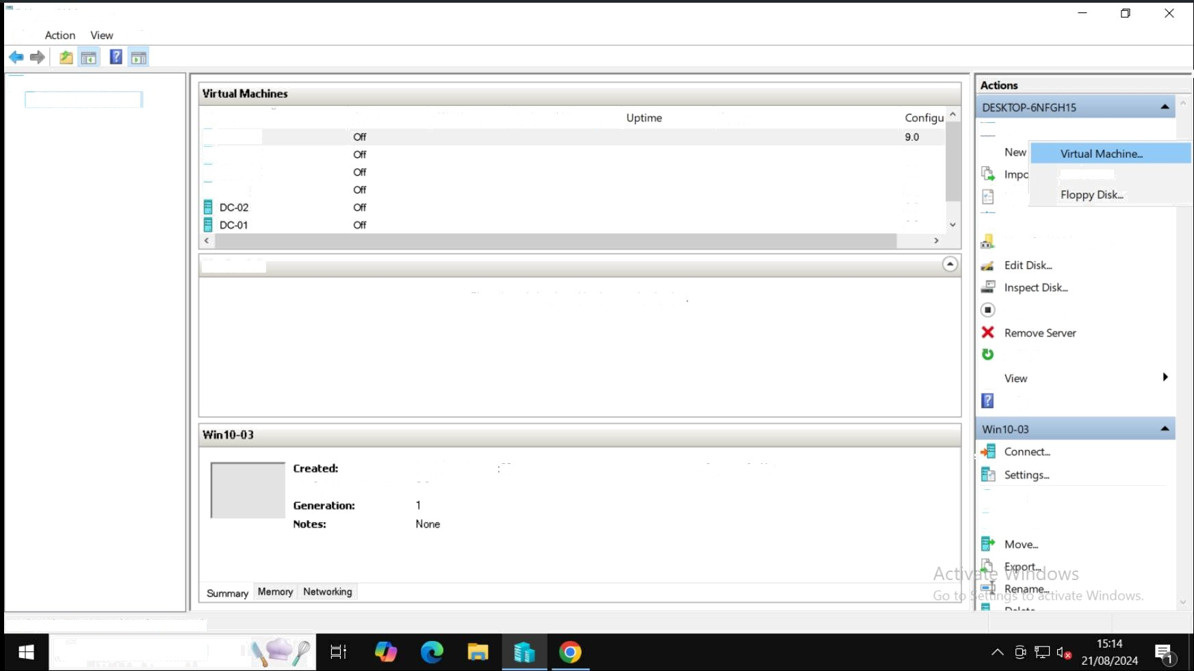,g 'd Hyper-V Ivlanager

File Help

Hyper-V Manager DESKTOP-bNFGH1$

Name

W10-03 V10-02 W10-01 DC-03

State CPU Usage Assigned Memory

The selected virtual machine hes no checkponts

14/08/2024 19:44 00

c«»r+guretiXsn Version: 9 0

Status

ClusCere¢h No

9O

9.0

9.0

9.0

9.0

*’* Ouick Creates

Hard Disk..

HyP^

Virtual Switch Manager.. Virtual SAN Manager..

Stop Service

Refresh

Help

Start

/» Checl‹point

Displays the New Virtual Machine Wizard.

## ,0 Type here to search

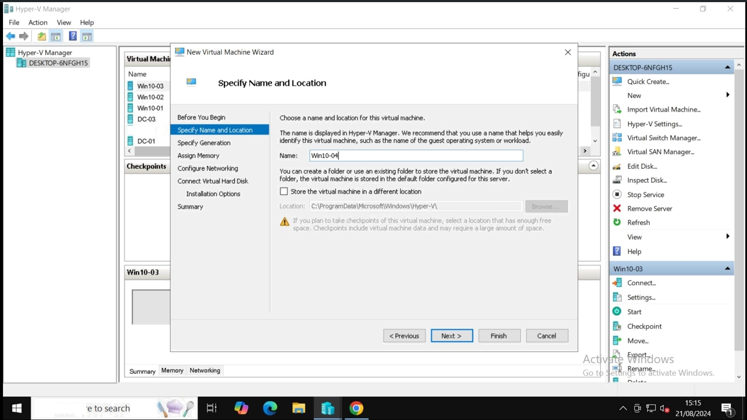DC42

### ,0 Type her

File View

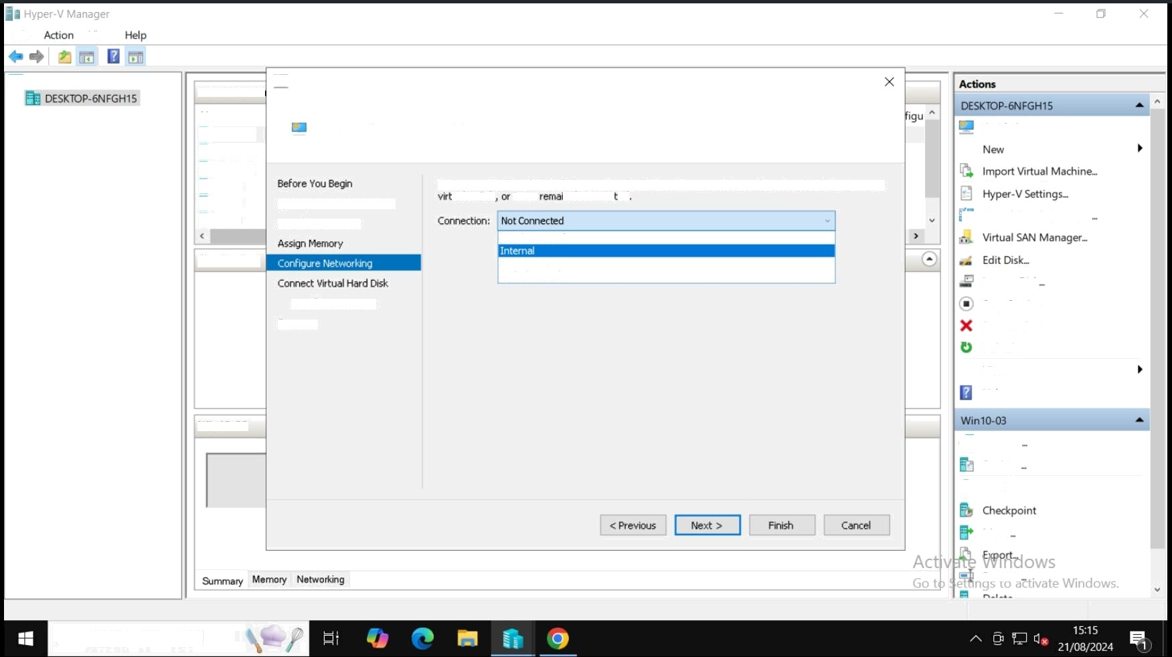

Hyper- V Manager

Virtud Maclg

Name

Wtn1043

@ Win1042

Wm10-0 1

DC-03

! New Virtual IVlachine Wizard

## Configure Networking

Each new véLud machine includes a network adapter. You Can configure Lie neLwork adapter to use a

Ouick Create.-

@ DC42 Specify Name and Location DCC â Specify Generation

Installation Options Summary

ua( switch it can n discorinec ed

Nor Connected

EXTERNAL

Default Swit¢h

, Virtual Switch Manager

lnspect Di sk Stop Service Remove Server Ref resh

View Help

COn n9Ct

Setti ngs

Move

Rename

## ,0 Type here to search

Virtual Mach Name

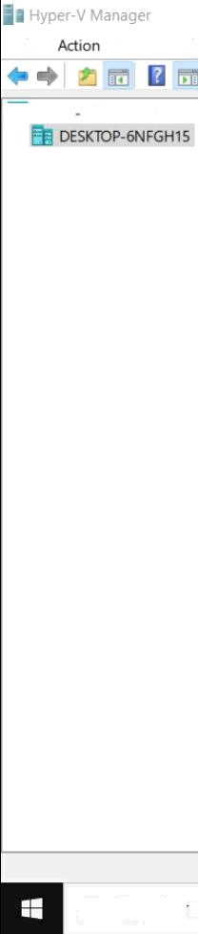

File

View Help

Hyper V Manager

,0 Type her e

' New Virtual Machine Wizard

Actions

DESKTOP-6NFGH1S



#### g n10.03 Connect Virtual Harct Disk

WIn10-02

@ Win10-01

*•-* Quick Cr eate

New

import Virtual Machine. .

DC-03 DC42 DC41

Before You Begin

Specify Name and Location Specify Generation

Assign memory

A virtual machine requires storage so that you can install an operating system. You can specify the stora-qe now or configure it later by modifying the virtual rriachir›e’s properties.

'9' Create a virtual hard disk

Use this option to create a VHDX dynamicafiy expanding virtual hard disk.

Hyper- V Setti r qs ..

, Virtual S 'itch Manager..

;-. Virtual SAN Manager...

Ck@C/ Q ” ¿on£iqur €* Netwo‹kng

Installahon Options Summary



mmqry Memory Networking

Name! Win10-01.vhdx  Locahon: C.\ProgramDaIa\M<rosoR\Windows\Virtual Hard Dsks\

3 GB (Maximum: 6P TB)

_ ' Use an existing vztuaI hard 6sk

Use th|s oqLlon to attach an existing virtual hard disk, either VHD or VHDL format.

: i ,

Attach a virtual hard disk later  Use this option to skp this step now and attach an elisting vir tual hard disk later.

< Prevaus rnsh Cancel



. Edit Desk... lnspect Dist ..

B Stop Service Remove Server Ref resh

View Help

W‹n10-03 “

ConneC/.

- Sett i ngs.



-• Checkpoint love...

. E'p.art... Rename..

## to seai cl -

File View Help

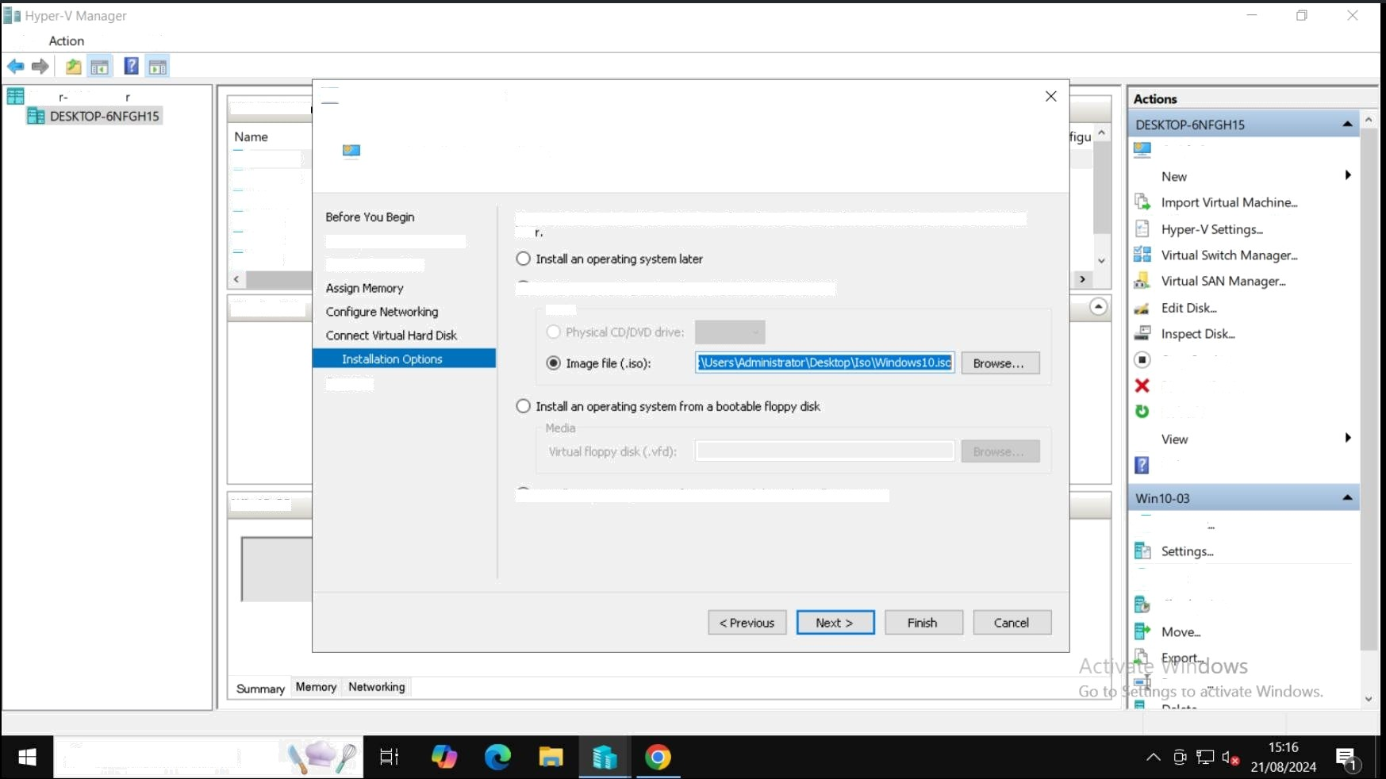

Hype V Manage

Virtual Macho

New Virtual Machine Wizarc{

Win10 03 Wln1042

Wn10-01

DC-03

# Installation Options

You can install as Operarrig system now £ you have acress to the setup media, or you can nstaJ it

Quick Creates

DC42 Specify Name and Location DCC Specify Generation

fare

' •.' Install an operating system ftom a bootable CD/DYD-POM Nedia

Stop Service Remove Server Refresh

' Install an operating system from a network based installaLion server

Help

Connect

Checkpoint

Rename

## ,0 Type here to searc I

DC41

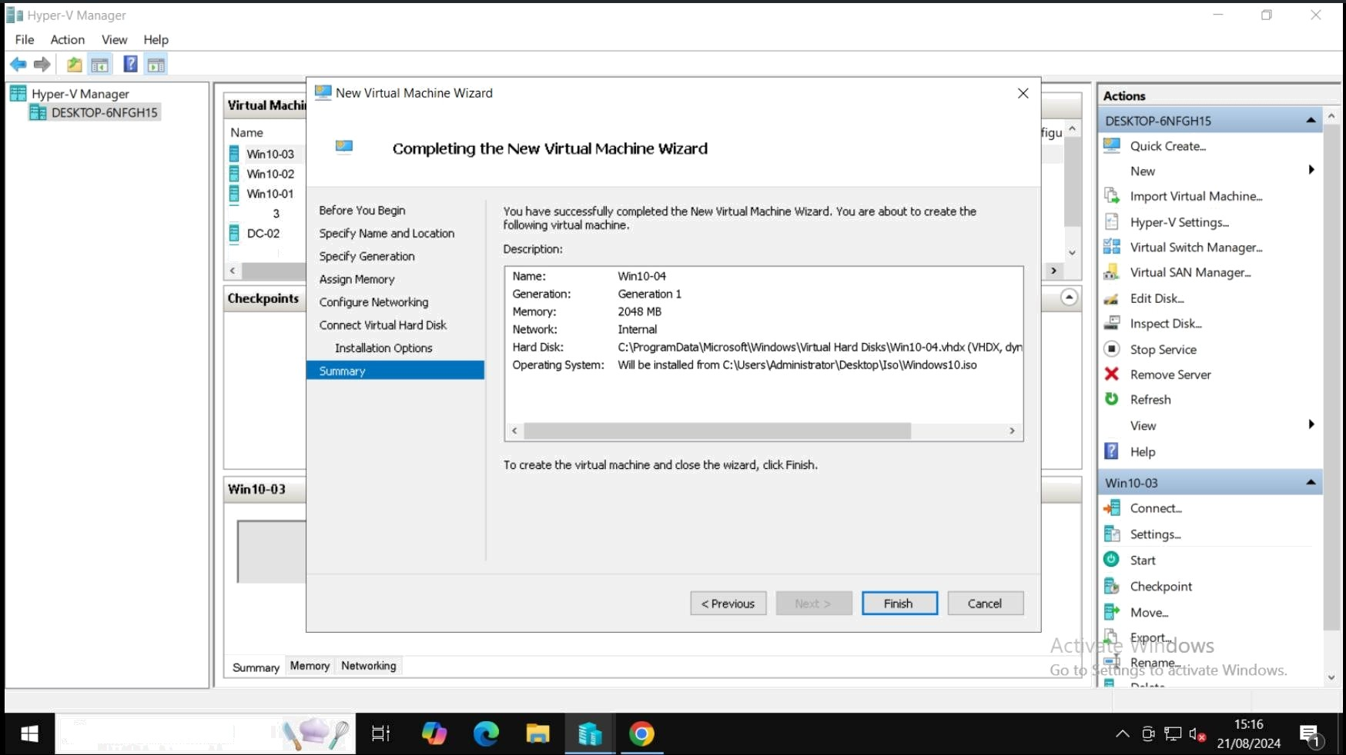

#### ,0 Typ e here to search

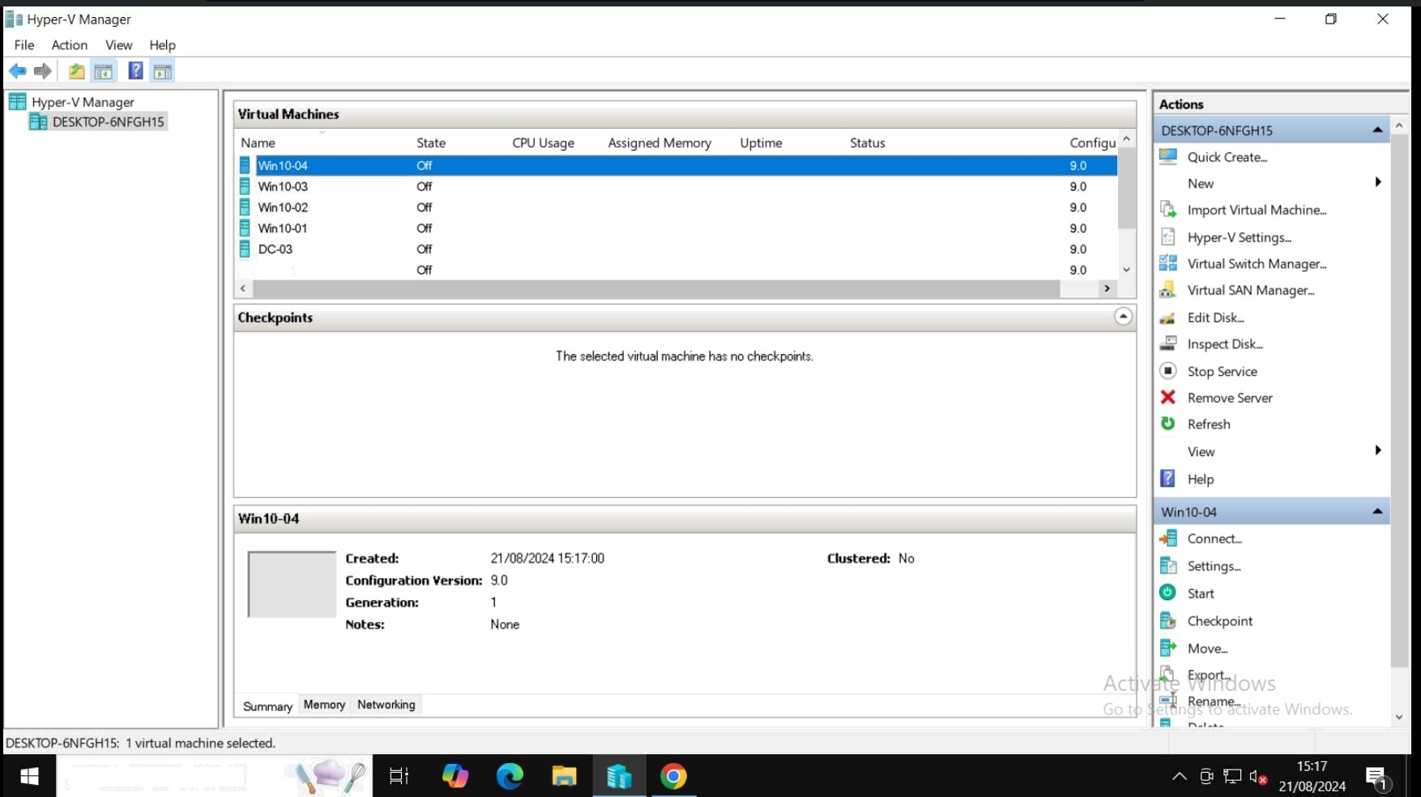@ DC42

,0 Type here to search

@ Win1 0-04 on DESKTOP-6NFGH 15 - Virtual Machine Connection Action

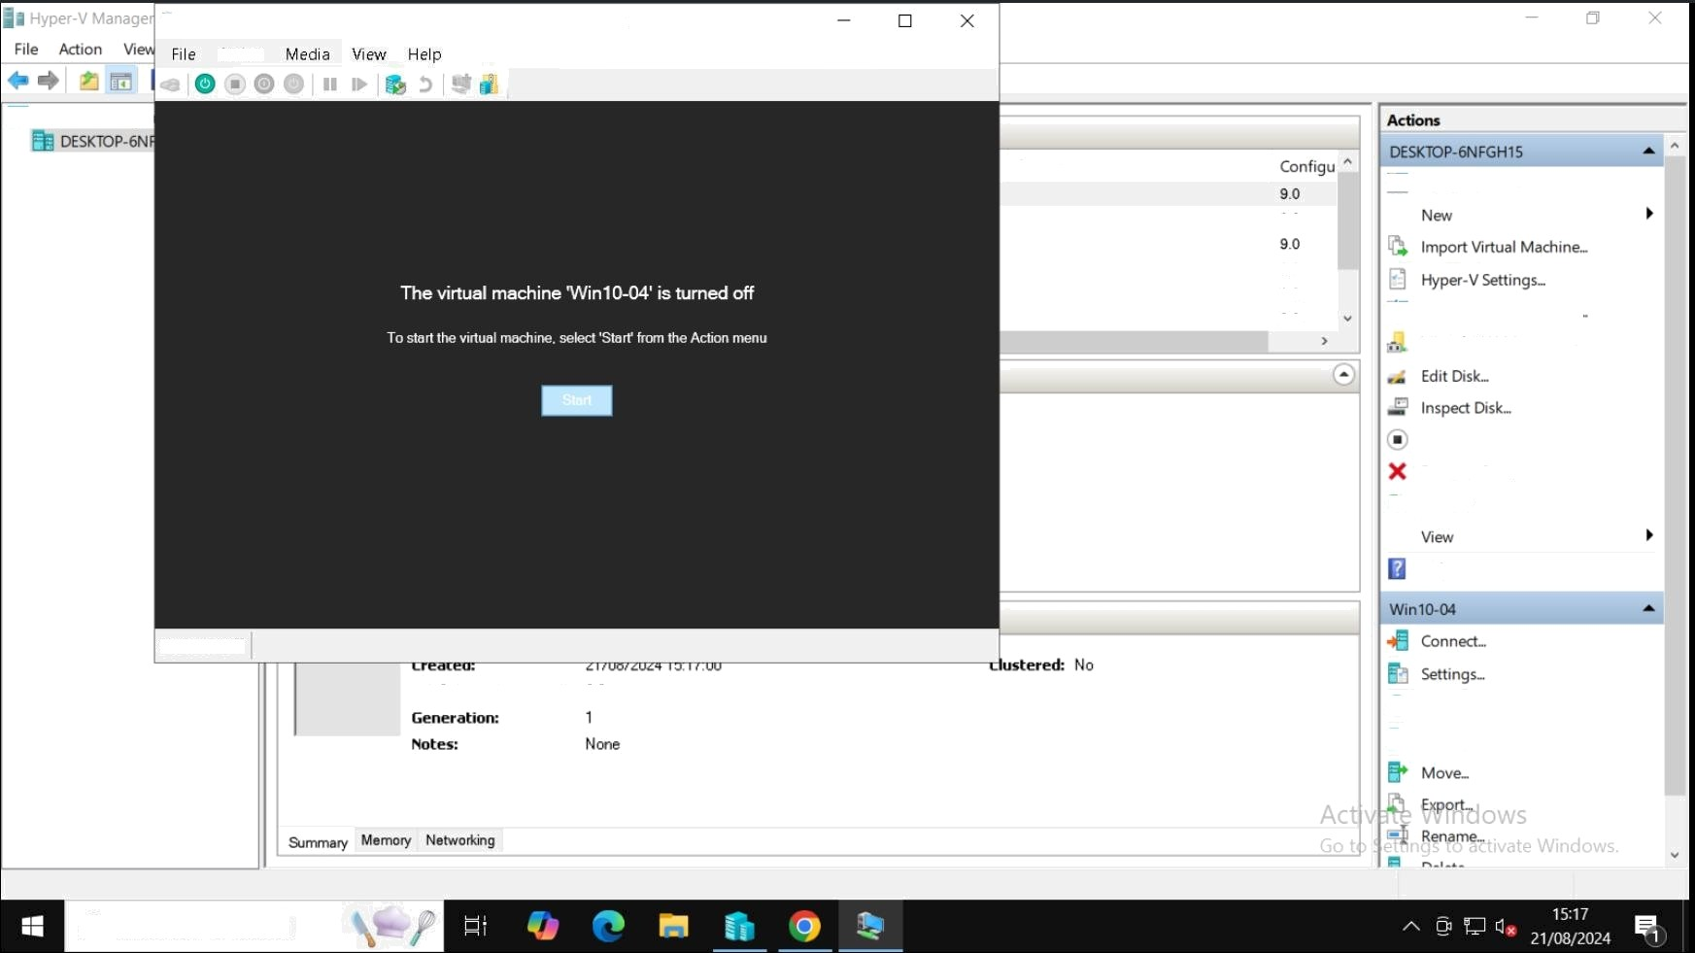

Hyper V Manage

Quick Creates

9.0

9.0

9.0

m Virtual Stich Manager.

Virtual SAN Manager...

Stop Service Remove Server Refresh

Help

States! Off

c »r+Duration Version: 9 0

Start

Checkpoint

## @ Type here to search

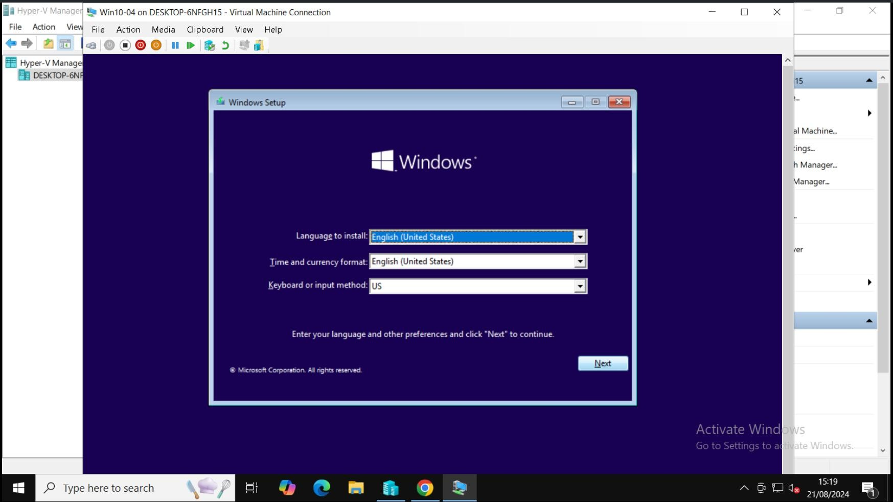

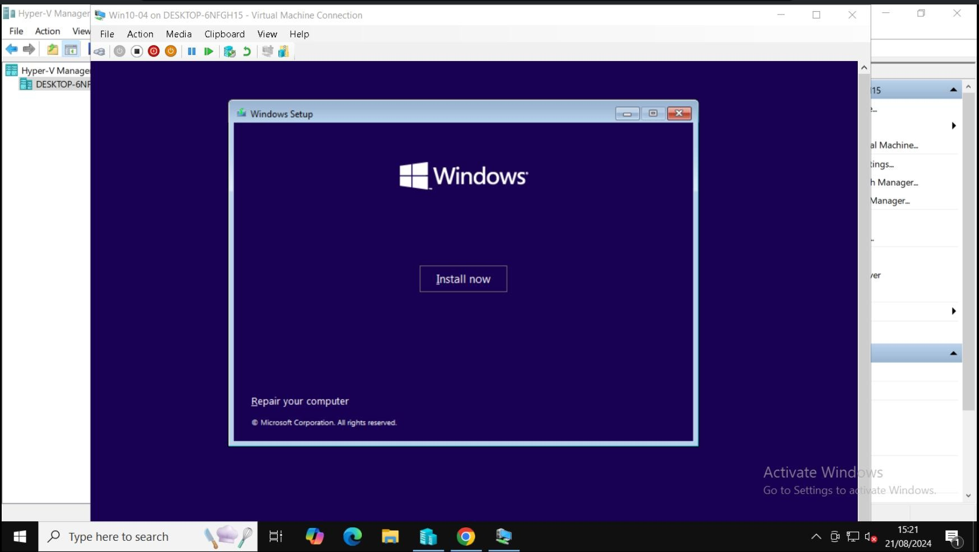

File

Hyper V Manage

Win10-04 on DESKTOP-6NFGH 15 - Virtual Machine Connection

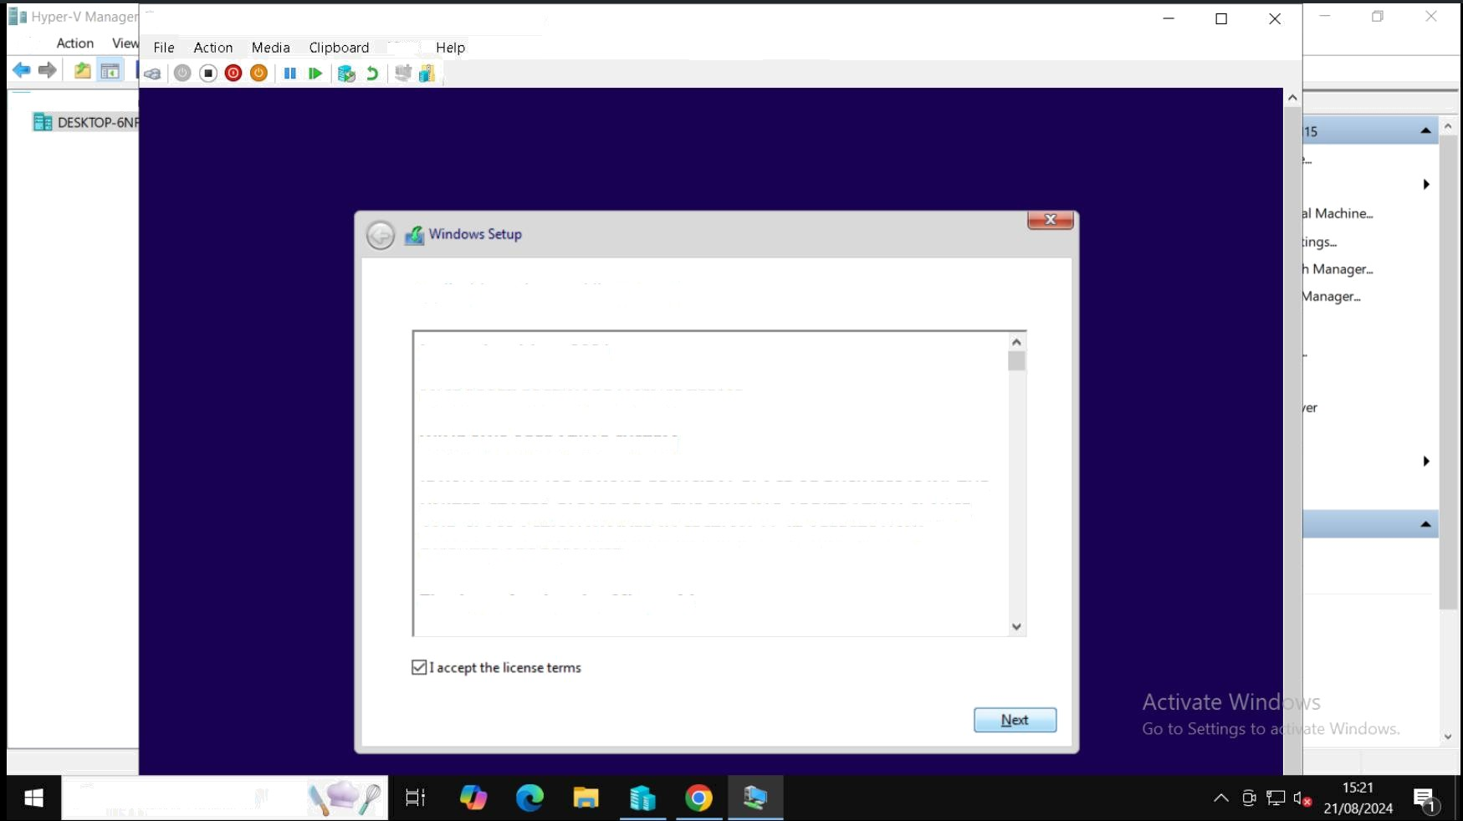View

# Applicable notices and license terms

Last updated June 2021

# MICROSOFT SOFTWARE LICENSE TERMS WINDOWS OPERATING SYSTEM

IF YOU LIVE IN (OR IF YOUR PRINCIPAL PLACE OF BUSINESS IS IN) THE UNITED STATES, PLEASE READ TFIE BINDING ARBITRATION CLAUSE AND CLASS ACTION WAIVER IN SECTION 1 1. IT AFFECTS HOW DISPUTES ARE RESOLVED.

Thank you for choosing Microsoft!

# @ Type here to search

vie I

Hyper-V Manage

*$s Win1D-04 on DESKTOP-6NFGH15 - Virtual Machine Connection

View Help

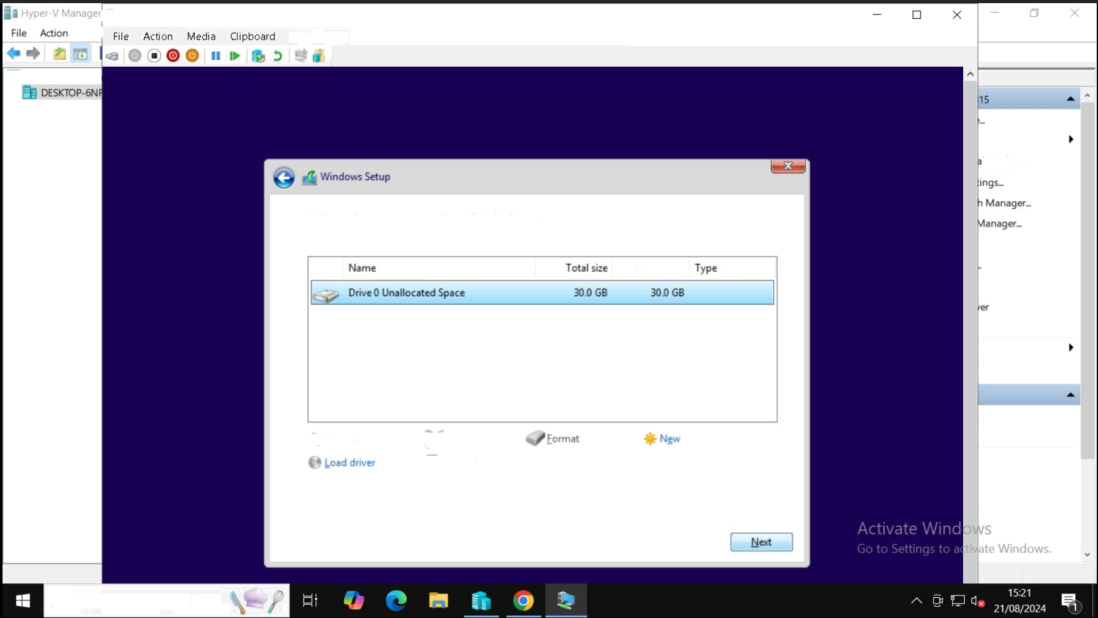

I Machines

# Where do you want to install Windows?

*j• Refresh

Cstend

# ,0 Type here to search

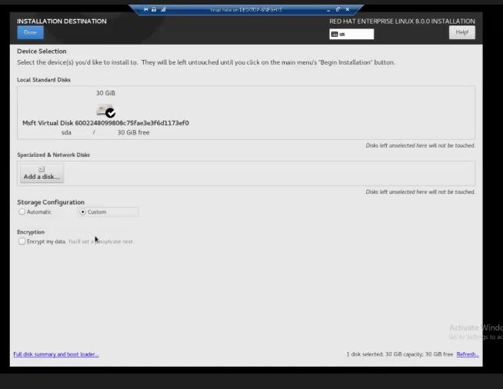

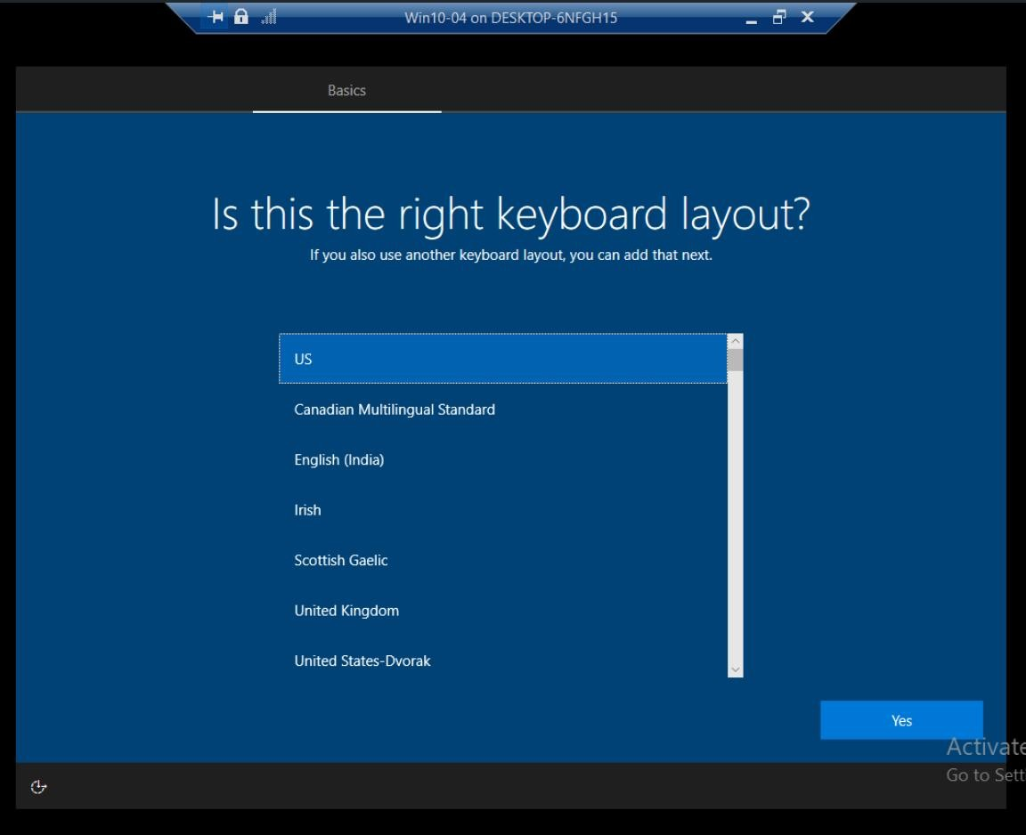

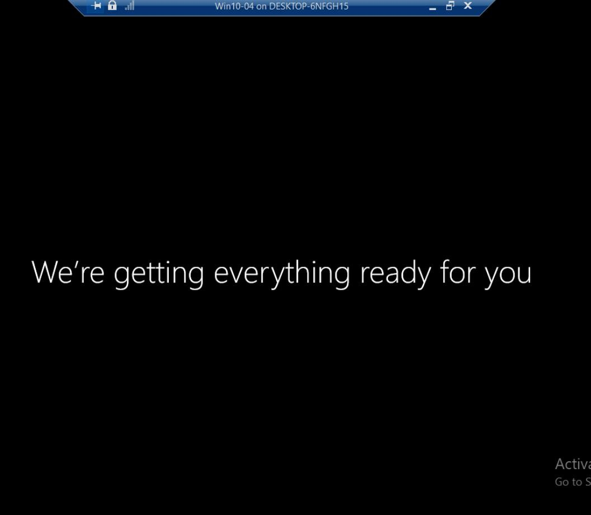





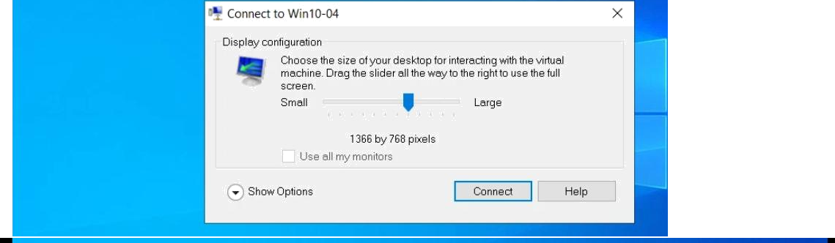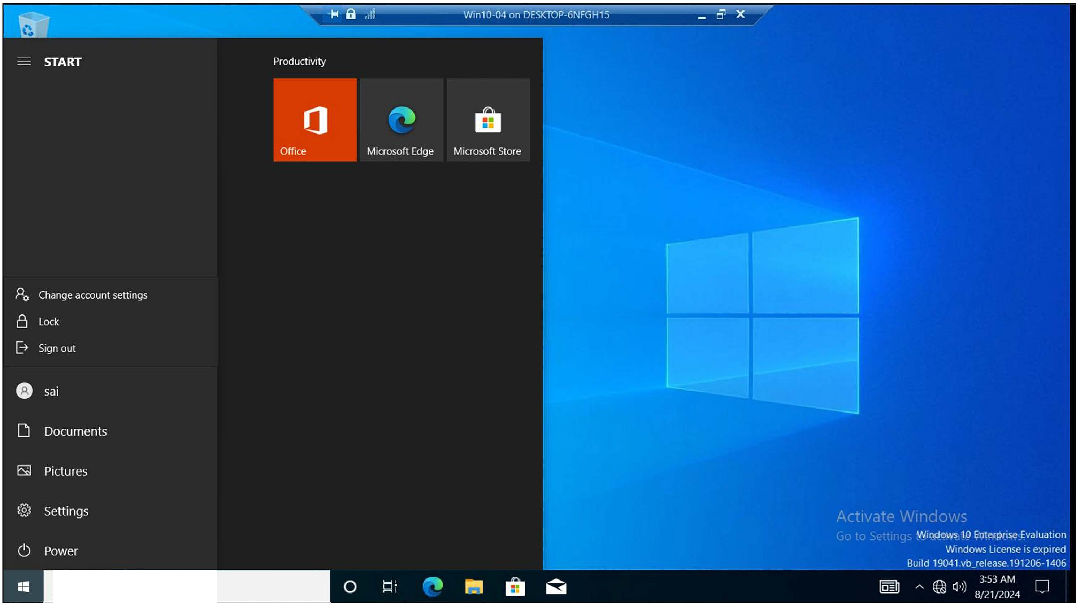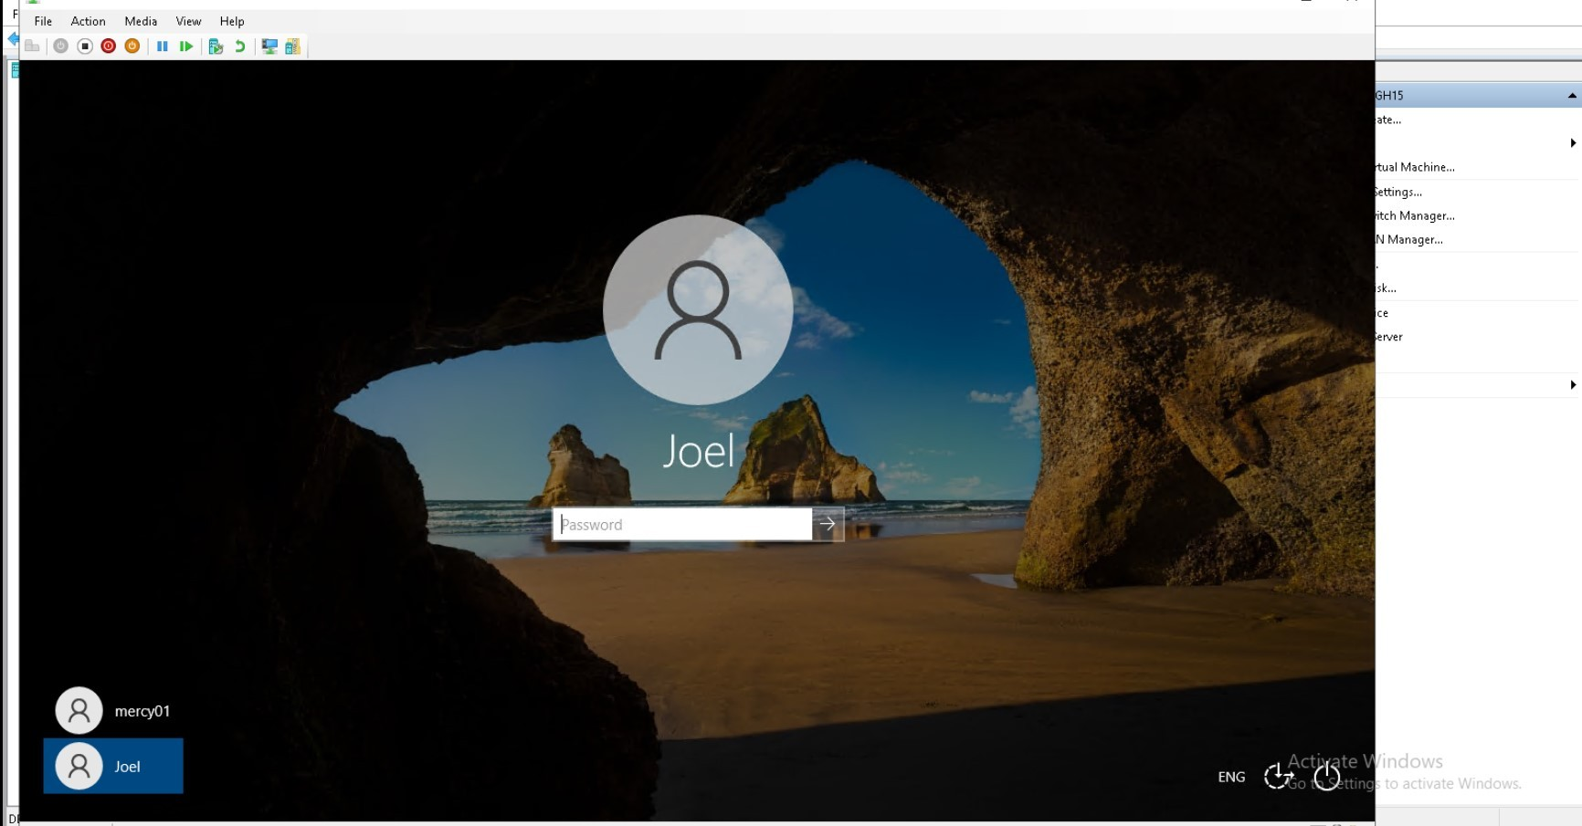

J) Type here to search